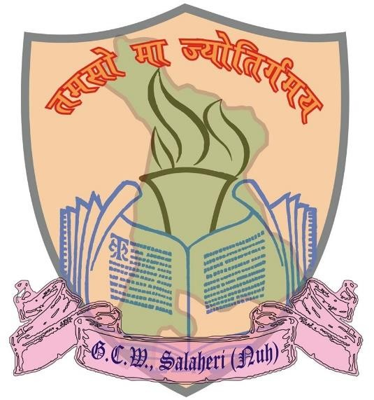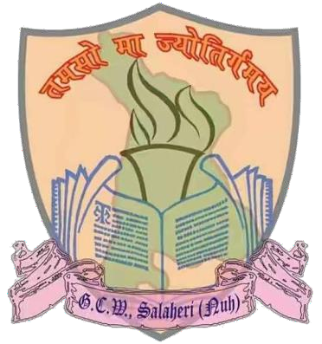
Saheed Le
Kiran She Govt Coll
Wo

(Affiliated from Guru
Salaheri (Nu
m
iutenant
khawat ege for en

gram University)
)-122107
h

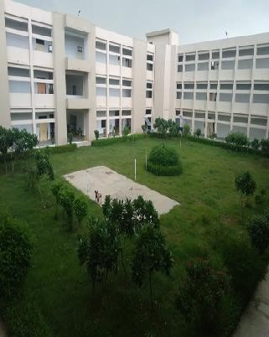  SAHEED LEIUTENANT KIRAN SHEKHAWAT GOVT. COLLEGE FOR WOMEN, SALAHERI (NUH)-122107  (Affiliated to Gurugram University) | ADMISSION BROCHURE  for admission to UG courses for the session 2023-24

Prospectus 2023-24

TEACHING STAFF OF THE COLLEGE

Smt. Madhu Arora
Principal

Sr. No | Name | Designation
01. | Sh. Ashok Kumar | Associate Professor
02. | Dr. Shruti Singh | Assistant Professor
03. | Sh. Tej Pal | Assistant Professor
04. | Sh. Manender Singh | Assistant Professor
05. | Dr. Ritesh Kumar | Assistant Professor
06. | Smt. Sarita Dahiya | Assistant Professor
07. | Dr. Anil Kumar | Assistant Professor
08. | Sh. Abid Hussain | Extension Lecturer
09. | Dr. Nazir Hussain | Extension Lecturer
10. | Dr. Jahan Nazir | Extension Lecturer

Page | 1

Prospectus 2023-24

CONTENTS

Sr. No. | Particulars | Page No.
1. | Our College | 3
2. | Admission Schedule for UG Courses | 5
3. | Guidelines For Applicants For Online Admissions | 8
4. | Infrastructure and Facilities | 11
5. | Departments | 12
6. | Course Structure | 14
7. | Ban of Ragging | 16
8. | Non-Teaching Staff | 18
9. | Student Support | 19

Page | 2

Prospectus 2023-24

Our College

VISION
Our aim is to become the leading transformative learning Institution that recognized in India for its excellence in education, skills, and research for social, cultural, and personal development. This institution will prepare the students that stand employable, independent, and sufficiently equipped with a viable set of life for the service of the nation.

MISSION

We are providing innovative knowledge and skills-based technological support to the students for their employment, growth, and development. We have adopted the best practices and highest quality teaching system to meet the challenges of life by developing communication skills and strength of personality development through training, information technology, and mentoring. This institution empowering the students, teachers, and parents for proper assimilation of culture and values of the Society.

OBJECTIVES

We aim to provide a world-class academic and social environment through extracurricular resources, both material and intellectual; so that graduates will be equipped with knowledge and skills to succeed in the world. Students receive a comprehensive education from this college by developing critical thinking, innovative abilities, and a mature heart so that they can transform the society around them.

HISTORY OF COLLEGE

The Govt. College for Women at Salaheri is placed in the heart of the Nuh District. The Institution was established in the year 2012. The Institution has a unique distinction in that its foundation stone was laid down by the Chief Minister of Haryana, Sh. Bhupender Singh Hooda

Page | 3

Prospectus 2023-24

in the year 2012. The College was worthily blessed and later on inaugurated by Chief Minister of Haryana, Sh. Manohar Lal Khattar in the year 2016.
This Institution is merely at a distance of 1.5 KMs from the Main Bus Stand of Nuh and 10 KM from Kundli-Manesar Expressway, One K.Mtr. from Delhi-Alwar Highway, and 15 KM from Rojka Meo Industrial Area of Nuh. The college is well covered by Haryana Govt. bus service from various important surrounding Nuh including Nuh bus stand, Sohna, Gurgaon, Firozepur Jhirkha, Rewari and Palwal, etc.
The College is one of the most prestigious institutions in the Nuh district of Haryana. This is the largest Girls College in the Nuh district where more than 500 girls’ students have enrolled. The foundation of the college rests on the dedication and enthusiasm of the staff, faculty, and students. The college has been steadily progressing in the fields of academics, sports, and cultural activities by leaps and bounds.
The college has fostering social responsibility and citizenship among youth by participating in various activities organized by cultural programs, Red Cross, NSS, and NCC camps. The College campus has nice greenery, beautiful lawns, and a well-maintained campus sprawling in 10 acres of most precious land. This Institution has won the One District-Green Champion Award from by Ministry of Education, MGNCRE.
Modern IT Labs like Language labs, computer labs, commerce labs, Psychological labs are helpful to increase the skills and knowledge of the students. Besides all the infrastructural modern facilities, the college has become a byword of excellence, intellectual and academic starving, extra-curricular activities, and a wide range of sports activities like Basketball, Badminton, Cricket, Tennis, and Table Tennis.

Page | 4

Prospectus 2023-24

Admission Schedule for UG Courses
For which online admissions shall be made by the Directorate of Higher Education, Haryana as per letter No. DHE-010019/6/2020-Coordination-DHE-Part (1) dated 12.06.2023 addressed to all Govt. Colleges, Govt. Aided and Self-Financed colleges in the State}
Schedule of dates for admission to Under-Graduate being run in the for the session 2023-24:

Sr.  No. | Title | Date/Timelines
1. | Online Registration of Admission Forms (Starting Date) | 17.06.2023
2. | Online Registration of Admission Forms (Last Date) | 28.06.2021
3. | Documents Verification & Preparation of Merit List | 17.06.2023 to 30.06.2023
4. | Display of 1st Merit List | 05.07.2023
5. | Submission of Fee (1st Merit List) | 10.07.2023 to 14.07.2023
6. | Display of 2nd Merit List | 15.07.2023
7. | Submission of Fee (2nd Merit List) | 17.07.2023 to 20.07.2023
8. | Re-opening of Online Admission Portal  for Registration towards Open Counseling for leftover seats | 21.07.2023
9. | Commencement of Teaching | 21.07.2023

Important Points regarding Centralized Online UG admissions:

- Once the seat is assigned to the applicant by the college during the 1st/2nd merit List on the specified date and time as per the Admission Schedule mentioned above. He/she will be asked to deposit the fee. The fee must be deposited as per scheduled time otherwise the seat will be canceled automatically.
- Applicants who were allotted the seat in the 1st /2nd merit but could not take admission or pay fee due to any reason, will get a chance of admission in open counseling only if they give

Page | 5

Prospectus 2023-24

their willingness online on the date of open counseling as mentioned above as specified in the schedule through their respective login on the Admission Portal.
- Applicants admitted after the 1st/2nd merit list as per the schedule can give their willingness to seek admission in the higher preference as declared by the applicants if available by the date as specified in the schedule. The only upward mobility of preference will be allowed.
- While Implementing the Reservation Policy on online admission software, rounding of the number of seats will be done and in case of mismatch during the bifurcation of seats by online admission software, the adjustment of the number of seats will be done in Haryana Open General Category.
- Merit lists will be prepared after considering all the weight age parameters along with the marks obtained in the qualifying examination for all categories viz. All India General Category. Haryana Open General Category, SC/BC Category, etc.
- The applicant whose admission is confirmed, will submit his original migration certificate if he/she is from any board other than Board of School Education Haryana, in the college within ten days of his/her admission so that, the same may be submitted by the college along with Registration Return to University.

Additional Guidelines Issued by DHE for the Session 2023-24
The admission guidelines/instructions issued by the Department of Higher Education, Haryana in session 2023-24 will be applicable during academic session 2023-24. However, additional guidelines are as follows; be also adhered to in letter and spirit. Further, fresh instructions, if any, shall be uploaded/displayed on https://highereduhry.ac.in and https://dheadmissions.nic .in from time to time.
  - Parivar Pehchaan Patra (PPP) shall be required for registration towards admission for Haryana residents.
  - Fee Structure shall be as per affiliating University/State Government norms.
  - Weight age for preparing the merit list during session 2023-24 shall also stand the same as was in session 2023-24.
  - The State Reservation Policy shall be followed in letter and spirit.
  - Merit lists shall be prepared after considering marks of the best five subjects in the qualifying examination including weight age and as per State Reservation Policy. ln addition, the provision of "Defer" the allotted seat by the applicant in the 1st Merit List for reconsideration in the 2nd Merit List will be provided subject to the condition that the applicant did not get his first choice in the 1st Merit list.

Page | 6

Prospectus 2023-24

  - Online Documents Verification shall be carried out by the college opted as the first choice by the applicant. All colleges including Govt. Colleges, Govt. Aided Colleges and Self-Financing Colleges shall be included during the process of Online Documents Verification.
  - The process of filling Sports Seats, if applicable, shall be ensured by the Colleges only during open counseling as per affiliating University/State Government norms.
  - The applicant whose admission is confirmed shall submit his/her original migration certificate in the college within ten days of admission if he/she has passed the qualifying examination from any Board other than Board of School Education Haryana.
  - Timely submission of Registration Return in the affiliating University shall be ensured by the Colleges only.
  - The colleges shall ensure that seats be filled according to norms only.
  - Refund, if any, to the students shall be ensured by the Colleges as per affiliating University/State Government norms. The college is also authorized to take the short payment, if any, from the student at a later stage as per norms.
  - No late fee will be charged from the applicants admitted through Open Counseling during the session 2023-24 due to the Covid-19 pandemic situation.
  - Registration on Online Admission Portal is mandatory for admission seekers. ln no circumstances, admission without registration on the portal shall be allowed.
  - The students will be initially given provisional admission only, subject to the verification of their documents by the College/Affiliating University. ln case of any discrepancy, the college is authorized to cancel the provisional admission of the student or change his/her stream/subjects subject to availability of seats & his/her willingness.
  - Queries regarding admissions, if any, be raised at email id: Toll Free Number 1800-180-2133 admissions@highereduhry.com (Helpdesk)
  - Implementation of Covid-19 guidelines/protocol issued by the State Government shall be ensured by the Colleges.

Page | 7

Prospectus 2023-24
Guidelines For Applicants For Online Admissions

- Weight age, Wherever applicable, would be given after verification of the uploaded documents and the applicant shall be provided with a maximum weight age of 10 marks.

Weight age (maximum 10 marks)

  - Recipients of National Talent Award from the NCERT (5 marks)
  - For B.com. 1st Semester, Students who have passed 10+2 examinations with commerce (5 marks)
  - N.C.C Cadets who possess the ‘B’ Certificate

OR

Holders of Bharat Scouts & Guides Certificate awarded by the President of India (for admission to the undergraduate course only)

OR

Sports Certificate for admission to UG courses. (5 marks)

Guidelines for Sports Weight age

Sports Certificate for weight age will only be considered. If the candidate produces the State/National position holder certificate from the respective State Government/Sports Department. In case, any state does not issue the Gradation Certificate, the following criteria will be adopted:

- In case of International/National participation or State Position Holder, a certificate of authenticity will be required from the concerned National Federation/State Association.

- The game/event must be in the scheduled list of the Association of Indian University Sports Calendar. c) The tournament must be organized by a recognized Federation/Association duly affiliated with the State Olympic Association/ Indian Olympic Association and Ministry of Youth Affairs & Sports.

Page | 8

Prospectus 2023-24

No weightage will be given for participating/winning positions in the sports and games organized by Nehru Yuva Kendra/CBSE National, Vidya Bharti Nationals/ Rural Tournaments/ Panchayat Tournaments/ Navodaya Nationals, and participation in non- recognized tournaments/sports festivals.

If 10+2 examination has been passed from a Rural Area of Haryana (5 Marks)

List of Documents to be uploaded online by the applicant:

  - Scanned copy of Passport size photograph
  - Scanned copy of the signature
  - Matric (10th) Marksheet
  - 10+2 Marksheet
  - Migration Certificate (required in case of other than Haryana School Education Board)
  - Character Certificate
  - National Talent Award from the NCERT/NCC/NSS/Sports/Bharat Scouts & Guides Certificate for weight age, wherever applicable
  - Bonafide Resident of Haryana Certificate, if applicable
  - Income Certificate required for claiming benefits of EWS or SC/BC Scholarships, if applicable
  - Parivaar Pehchan Patra (PPP Card)
  - Reserved Category, Certificate, if applicable
  - Gap. Year Undertaking, if applicable

- Name of the applicant will appear in the Merit List after online verification of documents as per eligibility/merit.

- General category students can now opt for ESW (Economically Weaker Section) quota within the Haryana General Quota. However, they need to upload the required certificate (Appendix H) for the same. 5. After final Selection, the admission charges shall be paid through online mode only. There is no provision of payment of admission charges physically at the College.

- After final Selection, the admission charges shall be paid through online mode only. There is no provision of payment of admission charges physically at the College.
Page | 9

Prospectus 2023-24

- All admission will be provisional. College/University will cancel any such admission if the information provided by the students is found to be fictitious/bogus at any stage and the student concerned will be held solely responsible for this

- If any document of a student is rejected due to some reasons during the process of online verification, a system-generated SMS will be sent to the applicant and the applicant will be required to re-upload the correct documents on the online admission portal by logging in his/her account within 48 hours of receiving that SMS. NO physical presence of the applicant shall be required to revise the documents.

- In the case of CGPA, convert it into marks/percentage as per the norms of the Board.

- A candidate can apply for multiple courses at a time. He/She can choose up to five colleges and up to five courses in each college. The candidate can further select a minimum of one and up to as many combinations as he/she wants.

- The applicant whose admission is confirmed, will submit his original migration certificate if He/She is from any board other than Board of School Education Haryana, in the college within ten days of his/her admission so that, the same may be submitted by the college along with Registration Return to University.

TERMS & VACATIONS

The schedule of terms and vacations shall be notified depending upon the situation of the COVID-19 Pandemic in due course of time.

Page | 10

Prospectus 2023-24

Infrastructure and Facilities

- 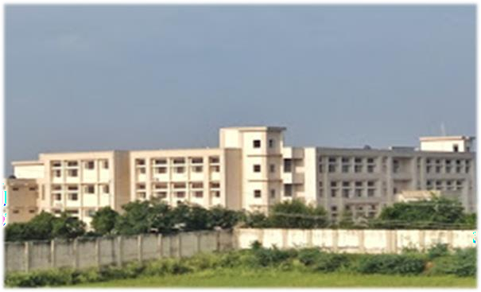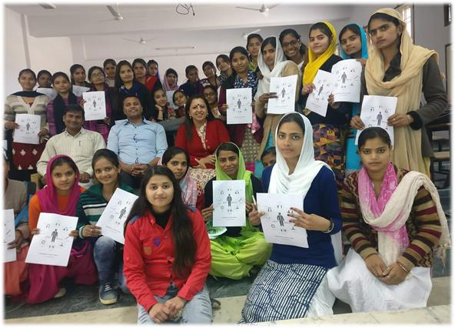Clean and Green Campus
- Solar Panels/Water Harvesting Plant/Sewage Treatment Plant
- Uninterrupted Electricity & Water
Supply
- Air Conditioned Library
- ICT enabled Smart Classrooms
- ICT enabled Seminar Hall
- 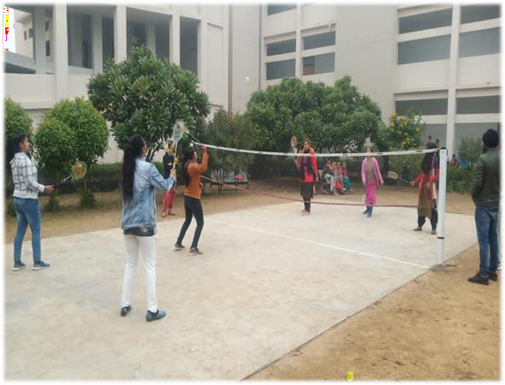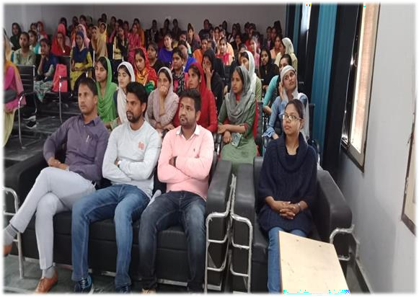Language & Lab with latest equipments
- Air Conditioned Computer Lab
- Psychology Lab
- Air Conditioned Commerce Lab
- Wi-fi Connectivity
- Girl’s Comman Room
- Badminton Court
- Basket Ball Court
- Indoor Games
- R.O Drinking Water
- Multipurpose Hall

Page | 11

Prospectus 2023-24

Departments And Faculty of the College
The College has highly qualified and experienced faculty. Many teachers have published academic and creative works in reputed national and international journals and attended various seminars and conferences. The Departments of the College regularly organizes extension lectures and activities to benefit both the students and teachers.
DEPARTMENTS AND FACULTY OF ARTS AND COMMERCE
The department of commerce has resourceful & efficient faculty. The Department gels formal academic course work with empirical education, and through its society. From time to time, the Department of Commerce has conducted various Workshops and Lectures to motivate the students and help in their career development. To build up administrative and managerial skills, students are motivated and given responsibilities of organizing various events. The faculty of the college is as follow:

Sr. No. | Name of Faculty | Qualification | Designation | Department
01. | Sh. Ashok Kumar | M.Com | Associate  Professor | Commerce
02. | Sh. Manender Singh | M.Com,  M.Phil | Assistant  Professor | Commerce
03. | Dr. Ritesh Kumar | M.Com,  M.Phil, P.hd | Assistant  Professor | Commerce
04. | Sh. Abid Hussain | M.Com | Extension  Lecturer | Commerce
05. | Dr. Shruti Singh | M.A, Ph.D. | Assistant  Professor | English

Page | 12

Prospectus 2023-24

06. | Dr. Nazir Hussain | M.A, Ph.D. | Extension  Lecturer | English
07. | Sh. Tej Pal | M.A (Hindi) | Assistant  Professor | Hindi
08. | Smt. Sarita Dahiya | M.A  (Psychology) | Assistant  Professor | Psychology
09. | Dr. Anil Kumar | M.A, P.hd | Assistant Professor | Political Science
10. | Dr. Jahan Nazir | M.A, Ph.D. | Extension  Lecturer | Urdu

Page | 13

Prospectus 2023-24

Course Structure

COURSE OFFERED AND SEATS AVAILABLE

Sr. No. | Course | Seats
01. | B.A Programme | 240
02. | B.Com (Pass Course) | 80
03. | B.Sc (Non-Medical) | Discontinue

MATRIX FOR DIFFERENT DISCIPLINE COMBINATIONS

Sr.  No. | Combination | Seats | Combination Fees (in ₹)
01. | English, Hindi, History, Political Science | 40 | 1200/-
02. | English, Hindi, Political Science, Psychology | 40 | 1260/-
03. | English, Hindi, History, Urdu (Elective) | 40 | 1200/-
04. | English, Hindi, Political Science, Urdu (Elective) | 40 | 1200/-
05. | English, Hindi, Political Science, Economics | 10 | 1200/-
06. | English, Hindi, Urdu (Elective),Psychology | 40 | 1260/-
07. | English, Hindi, History, Economics | 30 | 1200/-

Page | 14

Prospectus 2023-24

COURSE WISE ANNUAL FEES (FIRST YEAR)

Sr. No. | Course | Fees (in ₹)
01. | B.A ( Pass Course) | 4340/-
02. | B.Com (Pass Course) | 4592/-
03. | B.Sc (Non-Medical) | 4340/-
Note: The final fees for B.A and B.Sc might be vary based on the subject combination selected.

Page | 15

Prospectus 2023-24

BAN OF RAGGING

The instructions for curbing ragging as conveyed the UGC vide letter No. 1- 15/2009 (ARC) pt. III dated 17.03.2017, in view of the judgment of the Hon’ble Supreme Court of India dated 08.05.2009 in Civil Appeal No. 887/2009 and also given in Chapter X be adhered to strictly (UGC Regulations on Curbing the Menace of Ragging in Higher Education Institutions, 2009, UGC website: www.UGC.ac.in & the Haryana Prohibition of Ragging in Educational Institution Ordinance 2012.

Ragging in educational institutions is banned and any one indulging in ragging is likely to be punished appropriately. The punishment may include expulsion/ suspension from the institution or classes for a limited period or a fine with a public apology. The punishment may also take shape of (i) withholding or withdrawing scholarships or fellowships and other benefits (ii) forfeiting campus placement opportunities or recommendations. (iii) debarring from appearing in any test or examination or other evaluation processes (iv) debarring from representing the educational institution in any regional, national or international meet, tournament, youth festival, etc. (v) withholding results (vi) suspension or expulsion from hostel or mess (vii) cancellation of admission (viii) lodging of FIR with the local police. If the individuals committing or abetting ragging are not/cannot be identified, collective punishment can be awarded to act as a deterrent.

Any disorderly conduct whether by words spoken or written or by an act which has the effect of teasing, treating or handling with rudeness any other students, indulging in rowdy or in disciplinary activities which causes or is likely to cause annoyance, hardship or psychological harm or to raise fear apprehension thereof in fresher’s or junior students or asking the students to do any act or perform something which such students will not do in the ordinary course and which has
Page | 16

Prospectus 2023-24

the effect of causing or generating a sense of shame or embarrassment to adversely affect the physique or psyche of a fresher or a junior student or any type of abuse through electronic media or wrongful confinement, use of criminal force, assault as well as a sexual offense, trespass, defamation or threat to defame will be deemed an act of ragging.

Hon’ble Supreme Court of India in SPL (C) No. 24295/2004 in the matter of University of Kerala V/s Council of Principals, Colleges of Kerala and others have ordered that if any incident of ragging comes to the notice of the authority, the concerned student shall be given liberty to explain to if his/ her explanation is not found satisfactory, the authority would expel him/her from the Institution.

Page | 17

Prospectus 2023-24
NON-TEACHING STAFF OF THE COLLEGE

Sr. No. | Name | Designation
01. | Mr. Om Prakash | Assistant
02. | Mr. Nikhil Srivastav | Clerk
03. | Mrs. Wazida Khan | Clerk to HEO
04. | Mr. Irsad | Restorer
05. | Mr. Mohd Soyab | Lab Attendant
06. | Mr. Aasu | Chowkidar
07. | Mr. Vishnu | Chowkidar
08. | Mr. Dilip | Chowkidar
09. | Mrs. Bimla Devi | Peon
10. | Mr. Sunil | Sweeper
11. | Mr. Gagan | Sweeper
12. | Mr. Liyakat | Gardener

Page | 18

Prospectus 2023-24

Student Support

ADMISSION COMMITTEE
The Admission Committee reviews the admission process and the student’s profiles (determined mainly through cut-off percentages). The Committee also looks into the grievances and is responsible for their mitigation. It ensures fair and smooth admission for all the applicants.
Nodal Officer: Mr. Manender Singh (gcwsalaheri@gmail.com)

Co-Ordinator (Commerce Stream): Mr. Abid Hussain Co-Ordinator (Arts Stream): Dr. Anil Kumar

Note: For detailed information, kindly download the information brochure issued by Gurugram University, Gurugram. All the information given above might be amended based on the notification issued by DHE, Haryana, and Gurugram University.

Page | 19

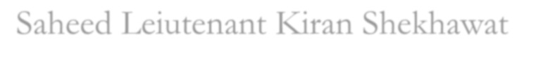
Saheed Leiutenant Kiran Shekhawat Govt. College For Women, Salaheri (Gurugram University, Gurugram) Email: gcwsalaheri@gmail.com
Website: gcwsalaheri.ac.in

